**PROXIMITY SENSORS**

Proximity sensors are basically of two types:

**1.INDUCTIVE PROXIMITY SENSOR**

**2.CAPACITIVE PROXIMITY SENSOR**

**1.INDUCTIVE PROXIMITY SENSOR**

At the heart of an Inductive Proximity Sensor is an electronic oscillator consisting of an inductive coil made of numerous turns of very fine copper wire, a capacitor for storing electrical charge, and an energy source to provide electrical excitation. The size of the inductive coil and the capacitor are matched to produce a self-sustaining sine wave oscillation at a fixed frequency.  The coil and the capacitor act like two electrical springs with a weight hung between them, constantly pushing electrons back and forth between each other.  Electrical energy is fed into the circuit to initiate and sustain the oscillation.  Without sustaining energy, the oscillation would collapse due to the small power losses from the electrical resistance of the thin copper wire in the coil and other parasitic losses.

*[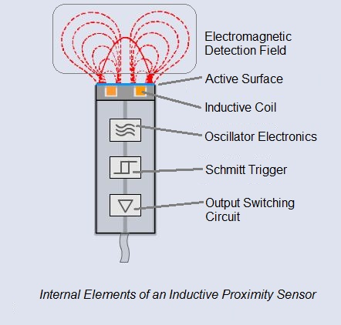](http://automation-insights.blog/wp-content/uploads/2014/03/inductive-proximity-sensor-cutaway-with-annotation.jpg)*

The oscillation produces an electromagnetic field in front of the sensor, because the coil is located right behind the “face” of the sensor.  The technical name of the sensor face is “active surface”.

When a piece of conductive metal enters the zone defined by the boundaries of the electromagnetic field, some of the energy of oscillation is transferred into the metal of the target. This transferred energy appears as tiny circulating electrical currents called eddy currents.  This is why inductive proxes are sometimes called eddy current sensors.

The flowing eddy currents encounter electrical resistance as they try to circulate. This creates a small amount of power loss in the form of heat (just like a little electric heater). The power loss is not entirely replaced by the sensor’s internal energy source, so the amplitude (the level or intensity) of the sensor’s oscillation decreases.  Eventually, the oscillation diminishes to the point that another internal circuit called a Schmitt Trigger detects that the level has fallen below a pre-determined threshold.   This threshold is the level where the presence of a metal target is definitely confirmed.  Upon detection of the target by the Schmitt Trigger, the sensor’s output is switched on.

**2.CAPACITIVE PROXIMITY SENSOR**

Capacitive proximity sensors are similar to inductive proximity sensors. The main difference between the two types is that capacitive proximity sensors produce an electrostatic field instead of an electromagnetic field. Capacitive proximity switches will sense metal as well as nonmetallic materials such as paper, glass, liquids, and cloth. The sensing surface of a capacitive sensor is formed by two concentrically shaped metal electrodes of an unwound capacitor. When an object nears the sensing surface it enters the electrostatic field of the electrodes and changes the capacitance in an oscillator circuit. As a result, the oscillator begins oscillating. The trigger circuit reads the oscillator’s amplitude and when it reaches a specific level the output state of the sensor changes. As the target moves away from the sensor the oscillator’s amplitude decreases, switching the sensor output back to its original state. 55 Standard Target and Standard targets are specified for each capacitive sensor. The Dielectric Constant standard target is usually defined as metal and/or water. Capacitive sensors depend on the dielectric constant of the target. The larger the dielectric number of a material the easier it is to detect.

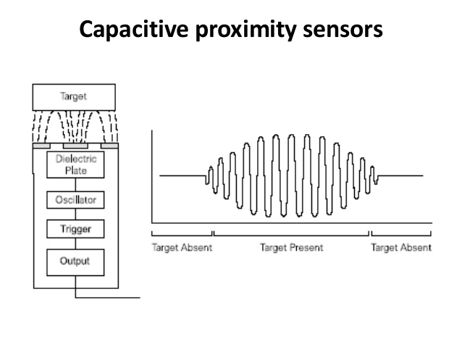

**Standard Target And Dieletric Constant For Capacitor Proximity Sensor**

Standard targets are specified for each capacitive sensor. The Dielectric Constant standard target is usually defined as metal and/or water. Capacitive sensors depend on the dielectric constant of the target. The larger the dielectric number of a material the easier it is to detect. The following graph shows the relationship of the dielectric constant of a target and the sensor’s ability to detect the material based on the rated sensing distance (Sr). The following table shows the dielectric constants of some materials. If, for example, a capacitive sensor has a rated sensing distance of 10 mm and the target is alcohol, the effective sensing distance (Sr) is approximately 85% of the rated distance, or 8.5 mm.

